**Your Participant Ce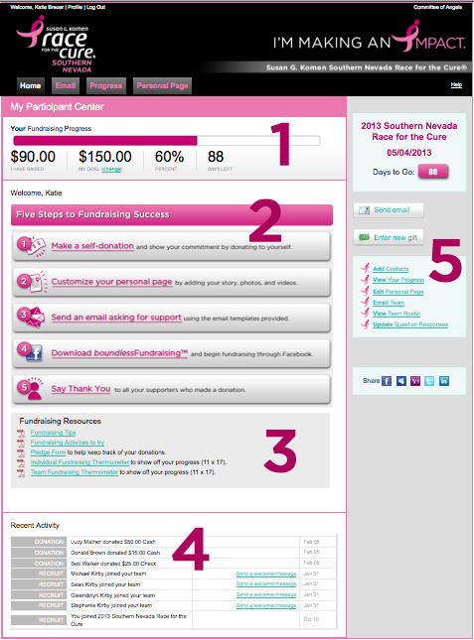nter - Individuals**

Welcome to your Participant Center!

You will arrive at your Participant Center Homepage.

1. This is your Fundraising Progress bar. It will update as you progress toward your fundraising goal.
2. The Five Steps to Fundraising Success section offers quick links to the five most important things you can do to successfully raise funds.
3. We offer several helpful documents to get you started, as well as some helpful fundraising tips and ideas.
4. Your Recent Activity is a very convenient tool. It provides you with updates on your activity.
5. Here you will find quick links to various actions within your Participant Center

Anyone who registers online is automatically given a Participant Center. You can access this by logging into our system using your User Name and Password.

Your Personal Page is a web page that your family and friends can visit to read about your personal fundraising efforts and make a donation to your fundraising goal.

**To log-in to your Participant Center, follow these instructions.**

* + - * 1. Click on the **Race for the Cure** tab at the top of our [homepage](http://www.komengreaterfortworth.org).

* + - * 1. Select the button that says **Participant Center**.
        2. This will bring you to the log-in page where you will enter your User Name and Password.
        3. You will be directed to your very own Participant Center, customized to you. This is where you will be able to edit your Personal Web Page, send out emails and easily track you and your teammates fundraising success.

To manually add contacts to Click the Email tab at the top of your Participant Center Homepage.

1. Click the **Email** tab at the top of your Participant Center Homepage.
2. Click **Contacts** on the navigation bar located on the right side of the page.
3. Click the **Add Single Contact** button on the right.
4. Enter the appropriate fields and click **Save**.
5. Click the **Email** tab at the top of your Participant Center Homepage.
6. Click **Contacts** on the navigation bar located on the right side of the page. The list of contacts from your address book displays. Select those you wish to receive your email message:

* Check the box next to the contacts you want to email.
* To email every contact in your address book, click **Email All**
* To email specific groups, click the **Groups** button above your contacts, next to the **Individuals** button.

1. To use a suggested message, click on **Template** below the Subject field. The message will appear and customize it how you like. You can also choose to compose your own message.
2. Before you send your email, be sure to insert your name at the bottom.
3. Under the email you will see sample layouts. Choose the image that you want to appear at the top of your email.
4. Click **Preview** above the contacts to see what your message is going to look like.
5. Click **Send**. A message will appear telling you that your email was successfully sent.

Send Emails to Your Friends, Family and Co-Workers

You have the option to create your own email or customize and edit one of the templates available to you.

Upload Your Contact List

To make it easy to send emails to friends and family, you can use the Address Book widget to easily import contact information from another address book application that you use such as Gmail, Yahoo! or Outlook. You can also import your contacts from a .csv excel spreadsheet.

1. Click the **Email** tab at the top of your Participant Center Homepage.
2. Click **Contacts** on the navigation bar located on the right side of the page.
3. Click the **Import Contacts** button on the right to access the online import tool.
4. Select the Email Application you wish to import your contacts from and click Next.
5. Enter the appropriate login information and log into your email account selected.

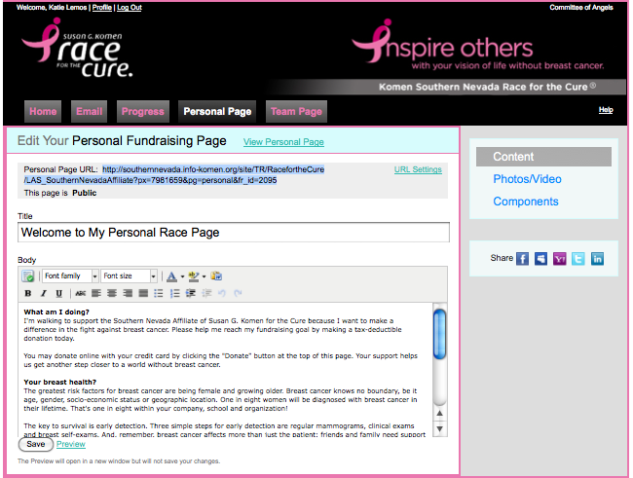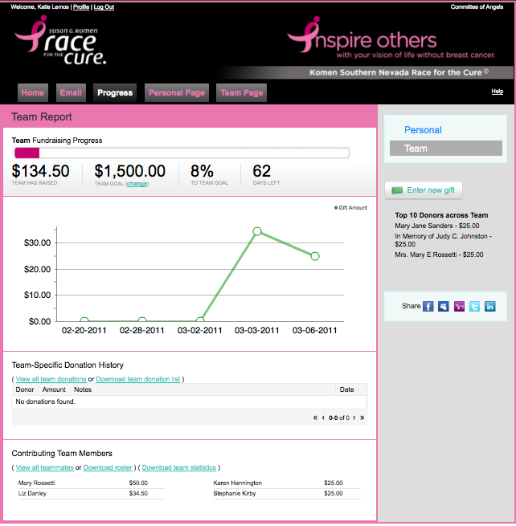

**To change your personal fundraising goal...**

1. Click on the link below the Fundraising Progress Bar that says change.
2. A small box will appear, enter your new goal and click Submit.
3. Your new goal will be updated.

* Below the graph on your Personal Progress Page, you will be able to turn off your gift notifications, view all personal donation or download your personal donations list.
* At the right, you will see your Top 10 Donors.

Click on the **Personal Page** tab at the top of your Participant Center Homepage.

Each Personal Page has a unique URL (we have highlighted it in blue). This is a direct link to your web page giving your donors an easy, quick way to make a pledge toward your goal.

Change the title of your Personal Page.

Optional, default text is already entered in the body area, but you may edit it however you like. Add your personal story or use your personal page to pay tribute to a loved one touched by breast cancer.

You may upload a photo or video by clicking on **Photos/Video** on the right.

**Components** will allow you to choose if you want to display your Fundraising Thermometer, personal blog or Fundraising Honor Roll on your web page.

Click **Preview** (near the bottom of the page). A separate browser window opens up to display your Personal Page. Make changes if necessary.

8. When finished, click **Save**. A message stating that your content was successfully saved will pop up.

Update Your Personal Page

Monitor Fundraising Progress

Simply registering and showing up on Race Day will raise awareness, but it’s your fundraising dollars that will get us to the cure. Monitoring your progress will motivate you to reach your fundraising goal. Click the **Progress** tab at the top of the Participant Center Homepage.

Your Personal Progress page will show up. This is where you can enter off-line donations that you receive (check or cash).

Entering Off-Line Donations

Your Progress Page is where all off-line donations are entered.

1. Click the button on the right of Progress Page that says **Enter new gift.**
2. A new page will load. Complete the requested information and click **Add**.
3. Your graph will be updated, however your progress bar will not. **Please note that your off-line donation WILL NOT show up on your progress bar OR your Personal Page until Komen receives the check or cash and confirms it in the system.**
   * + Mail all off-line donations (checks only) to...

*Komen Greater FW Race*

*2216 Green Oaks Rd.*

*Fort Worth, TX 76116*

* + - OR Drop off all off-line donations (check or cash) to...

*Komen Greater Fort Worth Office*

*2216 Green Oaks Rd.*

*Fort Worth, TX 76116*

**IMPORTANT**: Be sure a pledge form or some other form of identification accompanies your donation. We must be able to identify the donor as well as the recipient (you) in order to change your online entry to a confirmed donation.

Did you know you can add these to your Personal Page?

**Start a Blog...**

1. Click **Personal Page** from the options along the top of the page.
2. Click **Components** from the options on the right side of the page.
3. Here you have the ability to enable a personal blog feature by selecting **Enable Personal Blog**.
4. By doing this, you will be able to post updates directly to your Personal Page.

**Add a Photo...**

1. Click **Personal Page** from the options along the top of the page.
2. Click **Photos/Video** from the options on the right side of the page.
3. To Upload a new image, click **Browse**. After locating the file on your computer, click on the file and click open. The name of the file will display in the File Name field.
4. Click **Save/Upload**. A message will let you know your photo was uploaded successfully.
5. You have the option to add a caption. Click **Preview** to preview the changes to your page.

**Add a Video...**

1. Click **Personal Page** from the options along the top of the page.
2. Click **Photos/Video** from the options on the right side of the page.
3. To insert a link to a YouTube Video, click **Video** and manually enter the video link or copy and paste the path in the YouTube Video URL field and click **Save**.
4. Click **Preview** to preview the changes to your page. To change the video, close the preview page and repeat Step 3 with a new YouTube Video URL link.

**Create a Personalized Web Address...**

1. Click P**ersonal Page** from the options along the top of the page.
2. Above the title field to the right, click the link that says **URL Settings**.
3. Enter text is the allotted field. You can use your name, your team name or a nickname. To avoid any problems, do not leave any spaces in your customize URL name.
4. Click **Save** to save your changes. Remember that you can copy and paste this URL anywhere, sending people directly to your Personal Page.